EYFS – Reception Class
Within the continuous provision environment available in Reception class each and every school day, pupils always have access to a wide variety of art and design materials, resources and tools. They have opportunity to play, explore and develop knowledge, skills and interests in drawing, painting, collage, printing, textiles, sculpture and Art and ICT. High quality adult interactions enable pupils to develop their art, design and craft skills each day.

Group teaching of Art & Design knowledge and skills continues throughout the year. Within this children are introduced to specific vocabulary, knowledge and the use of skills and tools to develop their interests in Art and Design. This occurs with all the skills and processes including Drawing, Painting, Collage, Printing, Textiles, Sculpture, Art and ICT. These include the use of pencil, charcoal, chalk, paint, papers and card, textiles, ink, clay and computers. Pupils are also introduced to artists and craftspeople.

Early Learning Goals for Expressive Arts and Design:
- Safely use and explore a variety of materials, tools and techniques, experimenting with colour, design, texture, form and function.
- Share their creations, explaining the process they have used.

Term/Year | Year 1/ Term 1 | Year 1 / Term 2 | Year 1 /Term 3 | Year 2/ Term 2 | Year 2 / Term 2 | Year 2 /Term 3
Topic/skills/  processes  Theme | Wallpaper for Hedgehogs | Adventures at Sea | Zoo Animals | The Island | Dragon Eyes | Tinga Tinga
Drawing  Painting  Collage  Printing  Textiles  Sculpture  Art and ICT | Drawing – collections of leaves  Painting – mixing primary colours to match; tinting and shading  Printing – rubbings and plasticine monoprints | Drawing – boats and seascape  Painting – colour mixing, tints and shades, overlay with pastels for texture  Collage/Textiles – create boats/ships using different fabrics and papers. Use threads, ribbons, wool, sequins, buttons to embellish  Printing – repeated wave print for background  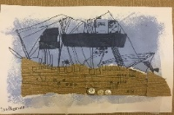 | Drawing – Marwell Zoo Visit and Zeraffa Giraffa by Diane Hofmeyr and Jane Ray.  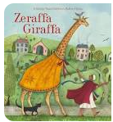  Painting – large scale animals  Sculpture - Follow Access Art Playful Making Pathway leading to the Sea Creatures outcome  Art and ICT – Digital Images for online gallery | Drawing – Isle of Wight Landscapes  Painting – Colour mixing over Hockney Landscape photocopies then own imitations. Paint in the style of La Roux using viewfinder snapshots.  Collage – Etel Adnan style collage from Isle of Wight pictures.  Printing - Etel Adnan style print from Isle of Wight pictures using polystyrene square and colour mixing inks. | Drawing – Dragon Eyes Tutorial.  Painting - Colouring pencil and felt tip then wax /oil pastels and brusho for texture.  Sculpture – Clay dragon eyes.  Art and ICT – Capture images of 3D art from different angles. Add to a background. | Drawing – exaggerated drawing in ink.  Painting – watercolour/chalk patel washes, oil pastel animals stuck on top  Textiles – Anna Wright animals ink drawings and patterned textile collage.  Large scale TingaTinga style animals – huge pieces of cardboard and bright poster paints.
Artist  Craftsperson  Designer | Comparison:  Nancy Wolff  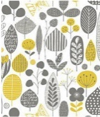  Orla Kiely  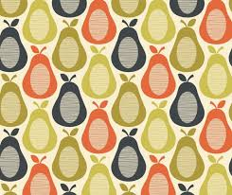 | Comparison:  Andrew Conway-Hyde – Isle of Wight  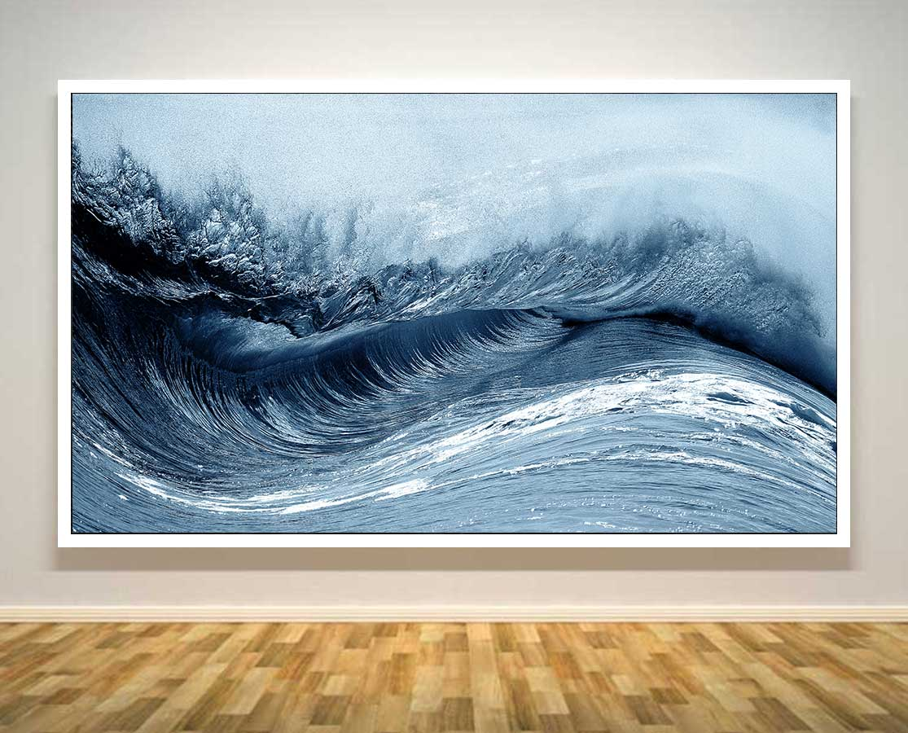  Winslow Homer – The Gulf Stream  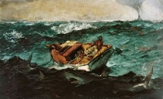  Katsushika Hokusai – The Great Wave  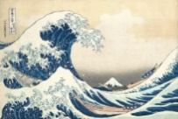 | Faith Bebbington  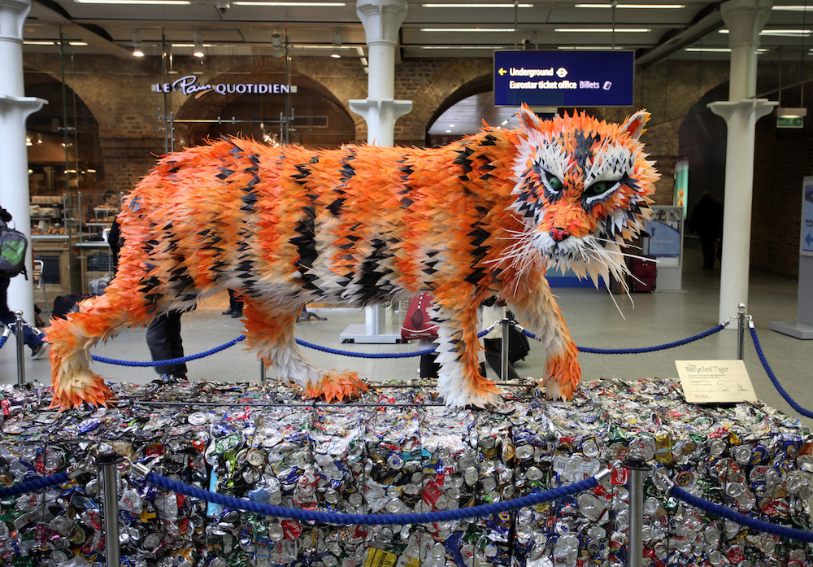  or  Anthony James (Arreton Barns)  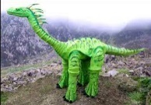 | Comparison:  Hockney (British)  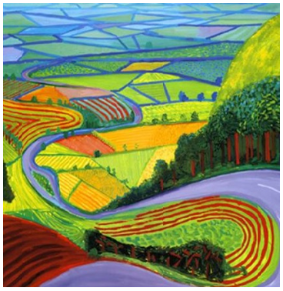  Etel Adnan (Lebanese American)  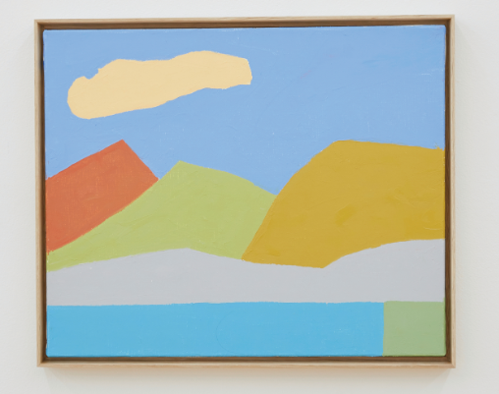  Isabel La Roux (South Africa)  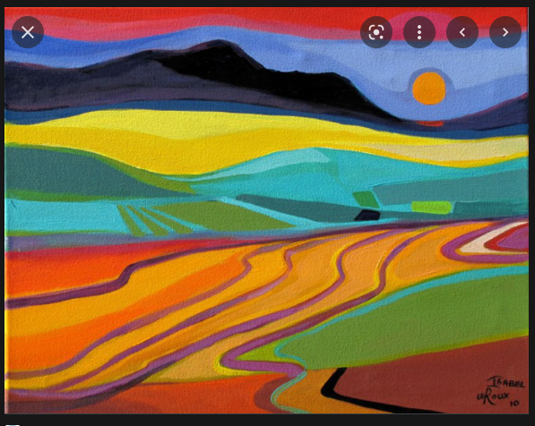 | Petr Horacek  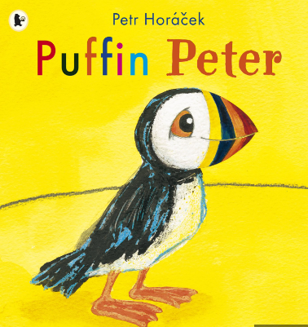 | Edward-Saidi Tingatinga  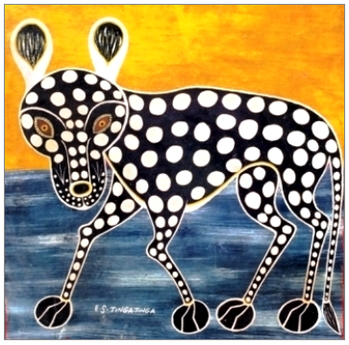  Anna Wright  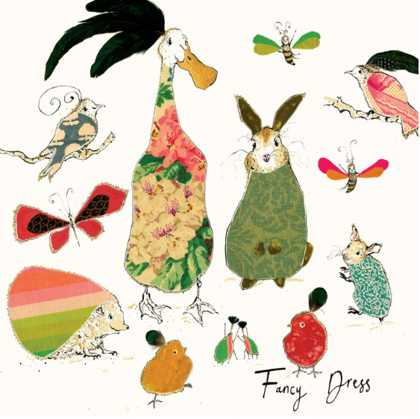
Colour, pattern, texture, line, shape, form, space | colour, pattern, texture  line, shape | colour, texture, line, form | colour, pattern, texture, form,  shape | colour, form, shape, line, texture, pattern | colour, texture, form, pattern | Colour, pattern, shape, space, line

Term/Year | Year 3 / Term 1 | Year 3 / Term 2 | Year3 /Term 3 | Year 4 / Term 1 | Year 4 / Term 2 | Year 4 /Term 3
Topic/skills/  processes  Theme | Pre-historic art | Rainforest | Volcanoes | Saxons and Scots | Anglo Saxon Pottery | Architecture: Castles - Collage
Drawing  Painting  Collage  Printing  Textiles  Sculpture  Art and ICT | Drawing – Exploring cave art. Drawing like cavemen with charcoal and chalk. Drawing people and animals in movement. Use pupils as models for quick, fluid large scale drawing.  Painting – painting final sculptures  Sculpture – creating animals and people with Modroc. | Drawing – John Dyer inspired  Painting – John Dyer inspired inks and pastel  Textile – weave on a homemade loom inspired by the colours, layers and patterns of John Dyer’s rainforest collection. Various fabrics and threads.  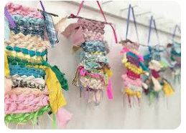 | Drawing – Draw onto Frank Bowling paintings using shape and texture to inform imaginative ideas.  Painting - Frank Bowling Painting  Printing – Multicoloured and layered monoprints of volcanos.  Art and ICT – Use a package to print and tessellate own image from above prints. | Drawing – from Bayeux Tapestry and then continuous line drawing object, simple object that would document this period in their life.  Painting – paint continuous line drawing.  Printing – Multi-layered monoprints of drawn image, exploring both positive and negative images.  Textiles – own sewn square of simple object chosen above.  Art ICT – create tapestry online | Drawing – artefacts from the time  Painting – artefacts from the time  Sculpture – creating and decorating pots. | Drawing - Light and Dark.  Painting – Light and Dark  Drawing/Painting/collage/Art & ICT –  Snapshot explorations of artists (below) works.  Take photos of local architecture for Street Collage. Over faded images to do initial explorations of architecture and buildings and especially line and shading. Then ink drawing and shading.  History link – collage castles.
Artist  Craftsperson  Designer | Alberto Giacometti  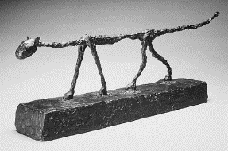  Lascaux Cave Paintings  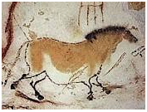  Joseph Beuys – German mid 20th century artist.  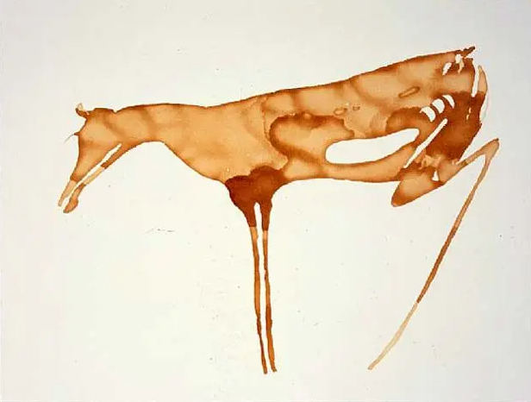 | Comparison:  John Dyer  inc. collaboration with Amazon Indian Nixiwaka Yawanawa  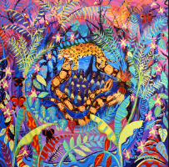  Henry Rousseau – Surprise!  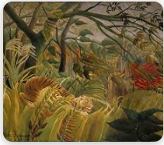 | Frank Bowling  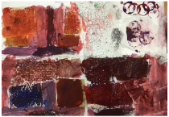 | Bayeux Tapestry  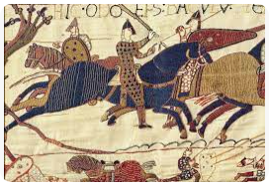  Constant Doodler  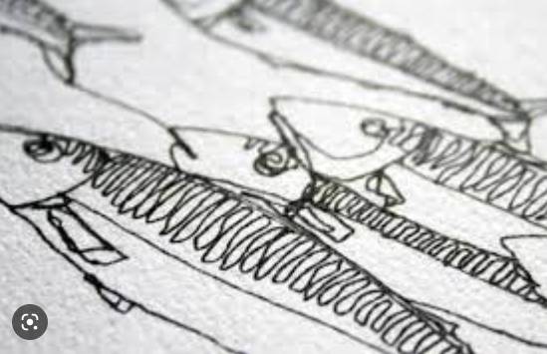  and  Harriet Riddell (InStitchYou) constant line drawing with a sewing machine.  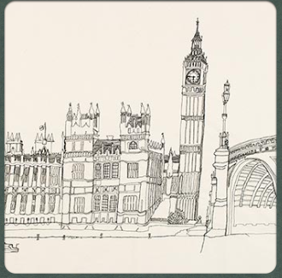 | Sue Paraskeva – Isle of Wight ceramic artist.  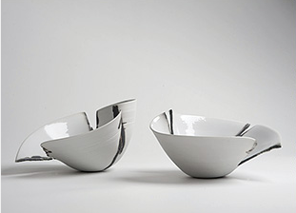  Christopher Maschinot | Stephen Wiltshire  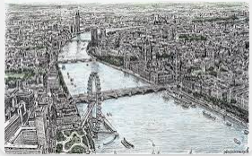  Collage Artists:  -David Crunelle  -Derek Gores  -Tracy English
Colour, pattern, texture, line, shape, form, space | line, shape, form, space | colour, pattern, texture, shape, space | Colour Pattern Texture | Line, texture, shape, space | Pattern, line, from, shape, texture | Line, shape, space

Term/Year | Year 5 / Term 1 | Year 5 / Term 2 | Year 5 /Term 3 | Year 6/ Term 1 | Year 6 / Term 2 | Year 6 /Term 3
Topic/skills/  processes  Theme | Space | Identity Portraits | Egyptian Artefacts | Abstract Portraits | Mayans | Industrialisation
Drawing  Painting  Collage  Printing  Textiles  Sculpture  Art and ICT | Drawing, painting – Exploring and imitating the work of Peter Thorpe in various media including pastels.  Textiles – select favourite element from drawing and paintings explorations and reimagine it with silk paint resists with sewn elements | Drawing – with ink to explore what you can infer about characters from the illustrations  Painting, Art & ICT, Collage – layered portraits with portrait photography | Drawing – from source materials, Ancient Egypt.  Painting, Printing, Sculpture – group sculpture project inspired by Egyptian wall painting. | Drawing – exploring the geometry and colour of Paul Klee and Wassily Kandinsky  Painting & Collage – Watercolour and pastel. Colour mixing and matching, tones, hues, tints. Variety of collage materials. Create village/city scenes and abstract portraits in style of Paul Klee. | Drawing – from 3D model of Quirigua sculpture on www.sketchfab.com  Painting – ink and watercolour sketches of Mayan and Gormley sculptures.  Sculpture – Layered clay sculptures. Shaping and joining techniques.  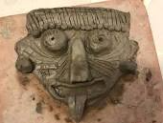 | Drawing  Painting  Collage  Printing using erasers and lino tools  Textiles  Art & ICT  Multimedia collage of newspaper, papers, textile, ICT, print erasers according to a brief detailing which elements and skills it must contain.
Artist  Craftsperson  Designer | Peter Thorpe  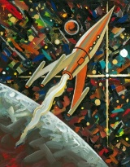 | Chris Van Allsburg  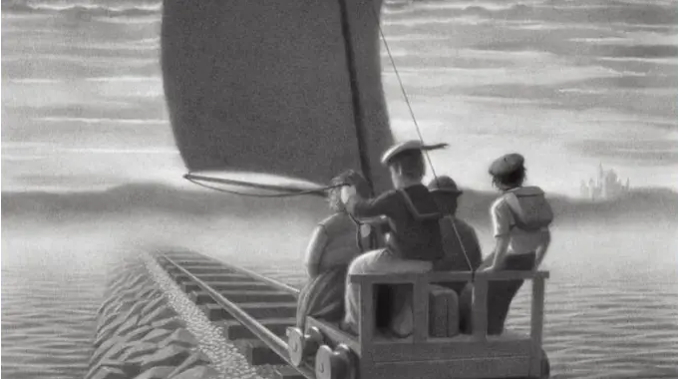  Local photographer - Alfie in the Air – Unison Street, Ryde | Nebamun Tomb Painting 1350BC  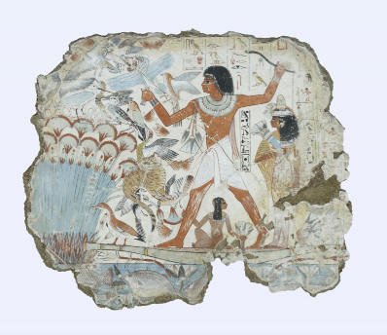 | Comparison:  Paul Klee  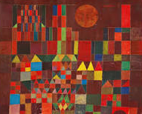  Wassily Kandinsky  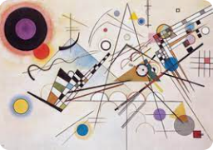 | Comparsion:  Mayan Sculpture  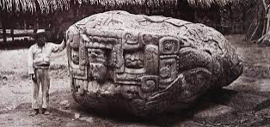  Anthony Gormley  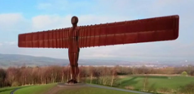 | Comparison:  LS Lowry  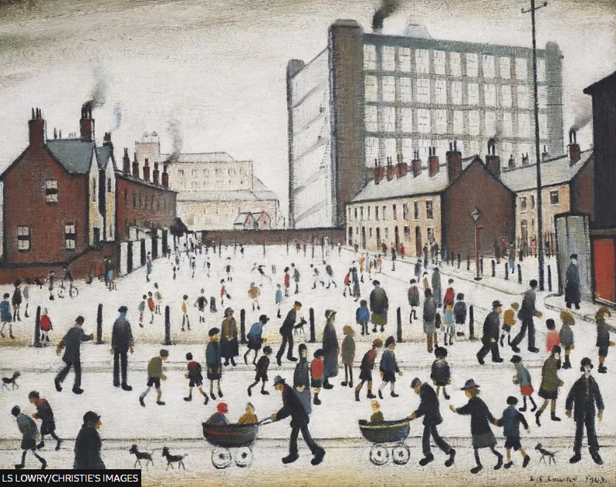  Commuter Photograph  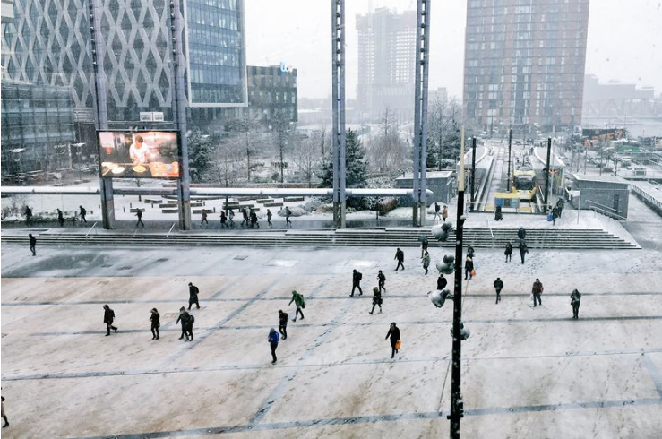  Also Nick Martin (Isle of Wight artist)  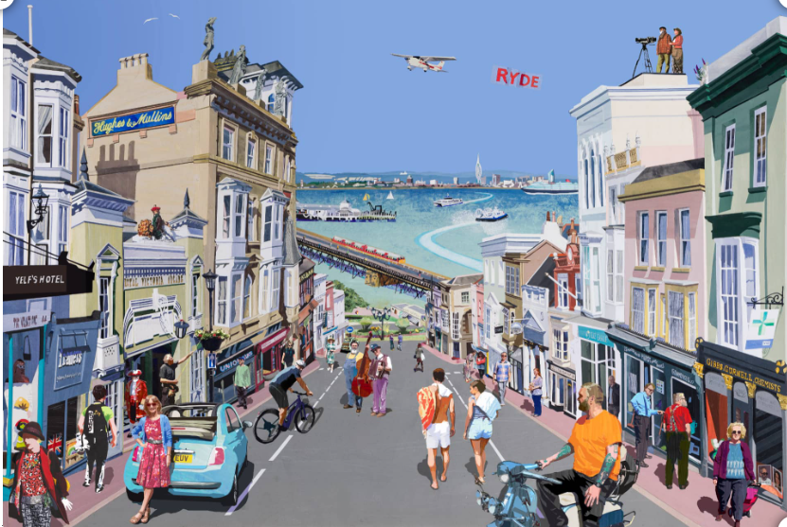
Colour, pattern, texture, line, shape, form, space | Colour, texture, shape, space, line | Colour, line, shape, form, space | Colour, pattern, line, space, form, texture | Colour, line, shape, space | Pattern, line, shape, form | Colour, pattern, texture, line, shape, form, space

